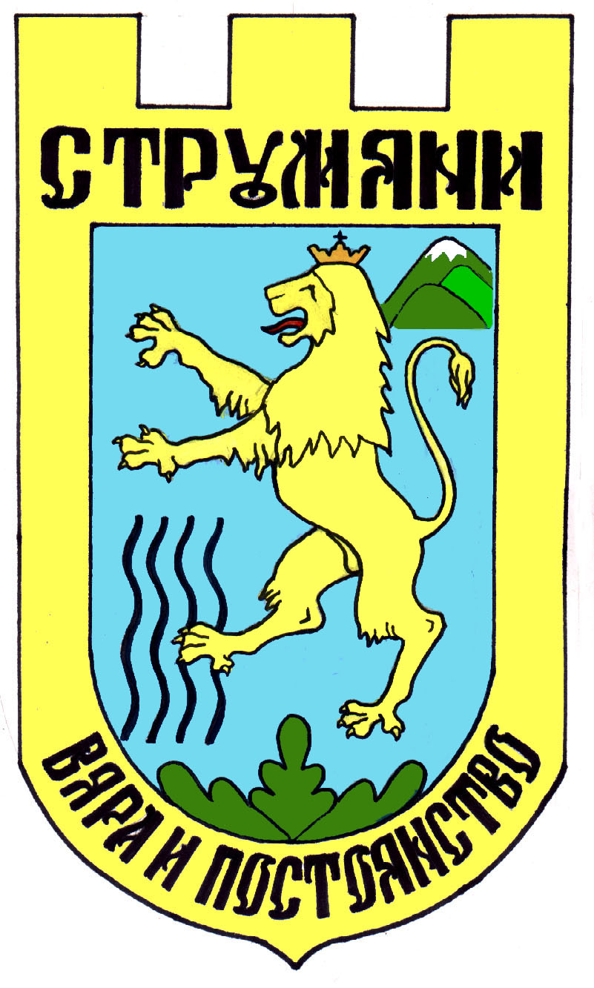
STRUMYANI MUNICIPALITY

Republic of Bulgaria, Region Blagoevgrad; Fax. +3597434 / 31-05, phone, +3597434/ 31-08

E-mail: strumyani_oba@yahoo.com



To…………………………..
……………………………

LETTER OF INVITATION

Dear Sirs,
We are happy to inform you that Strumyani Municipality - Bulgaria is the host and main organizer of the International Folklore Festival “Maleshevo sings and dances” – Mikrevo 2024, created with the basic purpose to keep and to perform the best of the singing and dancing art of Balkan nations.
The Festival will be held from October, 4th till October,6th 2024.

It is a great pleasure for us to invite your folklore group and individual performers to participate in the International Folklore Festival ”Maleshevo sings and dances” 2024.

Please, be so kind to confirm or to refuse your participation in The Festival not later than 6.09.2024!

For contacts and confirmation:
Telephone: + 359 07434/ 31-08
Fax: +359 07434 / 31-05
Mob: + 359 878 428 363
E-mail: maleshevopee@gmail.com ; strumyani_oba@yahoo.com

We are looking forward to see you at the Festival stage!

Emil Iliev,
Mayor of Strumyani Municipality
Bulgaria

